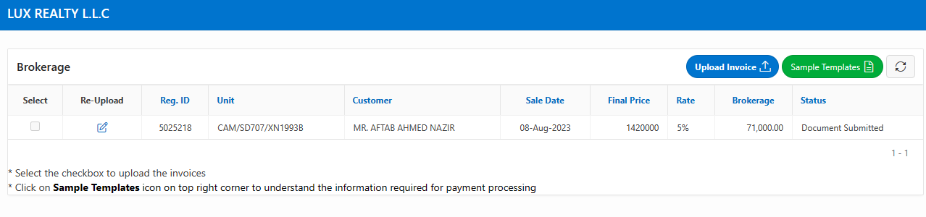

Uploaded on 23-Sep-23 at 8:00AM

